**Case Status /Work Status/Work Object Status/Field Value:**

**Purpose: To Know the Current Status of the transaction.**

**Status can be used to generate the history reports for a Business.**

**PRPC contains Predefined Status & depend upon requirement we can also add User Defined Status.**

**- Case Status can be defined using a Rule called : Field Value**

**What is purpose of Field Value Rule?**

**A: To Add User Defined Status**

**- Field Value is a Data Model Rule**

**- While Defining Field Value, the Status will be assigned to predefined Property pyStatusWork**

**Req: Modify existing Insurance Flow to assign below status to Work Object:**

**Start Shape: New ( Built -in)**

**Customer Assignment: Pending-CustInfo ( Used Defined)**

**Personal Vehicle Assignment: Pending-VehInfo ( User Defined)**

**End Shape: Resolved-Completed ( Predefined)**

**Add Filed Value Rule for adding below status:**

**1- Pending-VehInfo**

**Create Filed Value rule from Data Model Category:**

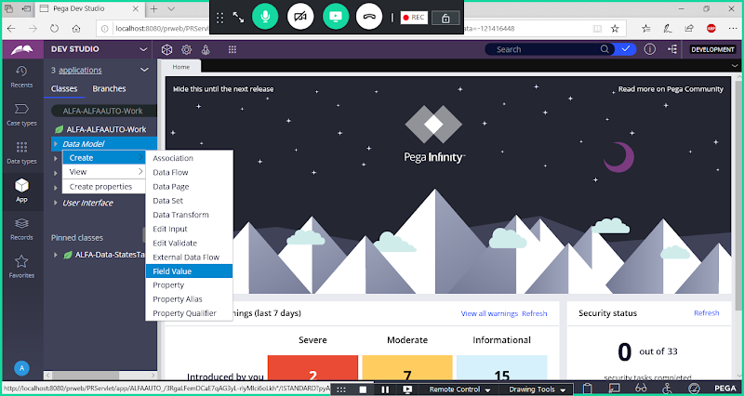

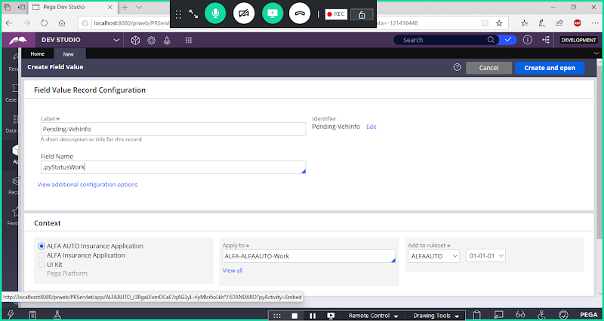

**Open**

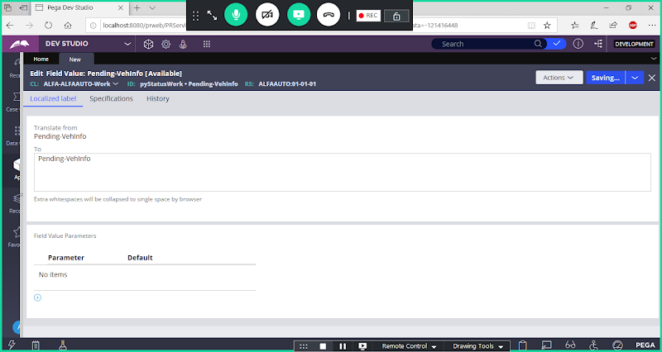

**Save Field Value**

**2- Pending-CustInfo**

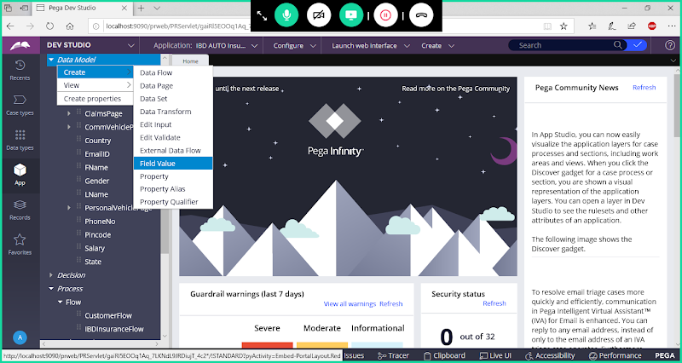

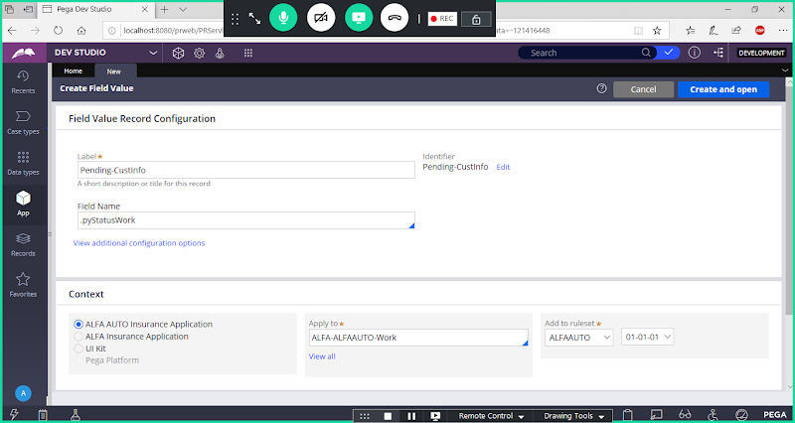

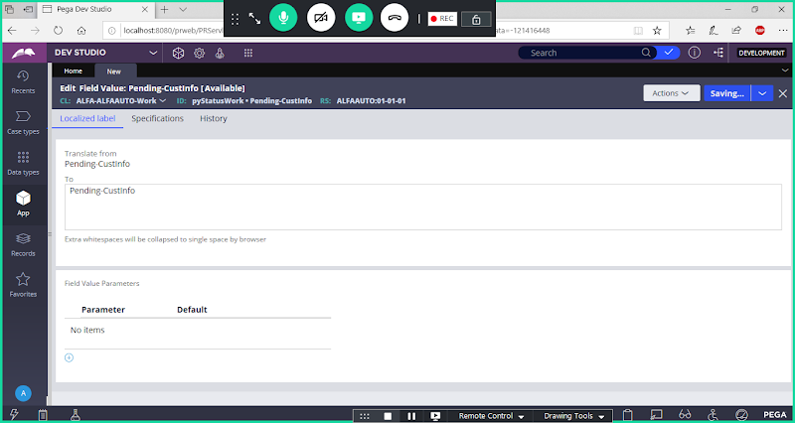

**Save**

**Now Open Flow & Add Status to all the Shapes**

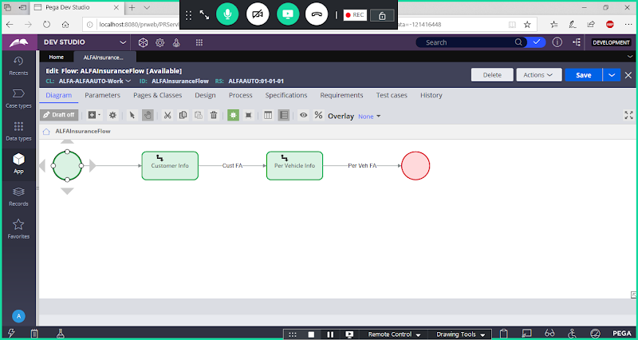

**Open Start shape Properties & Add status as New**

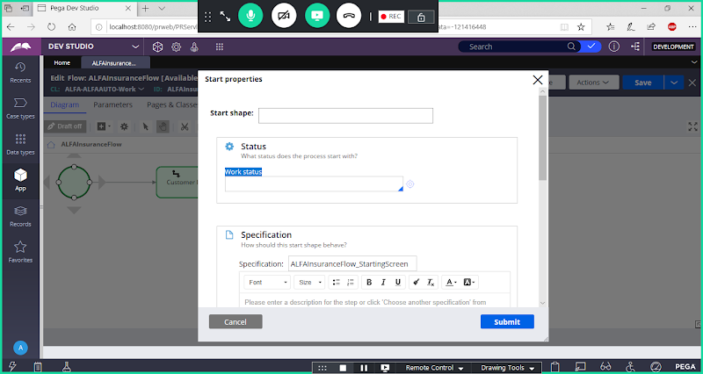

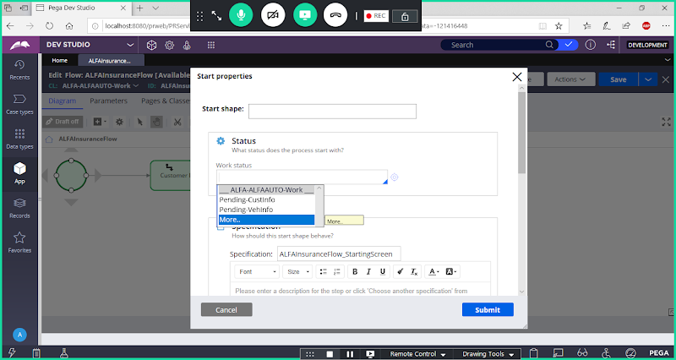

**Click on More to select Predefined Status**

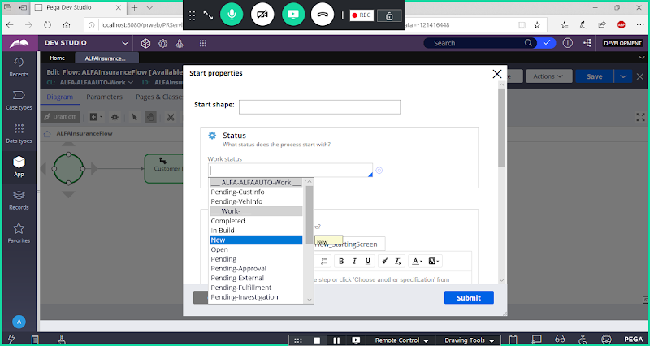

**Select New**

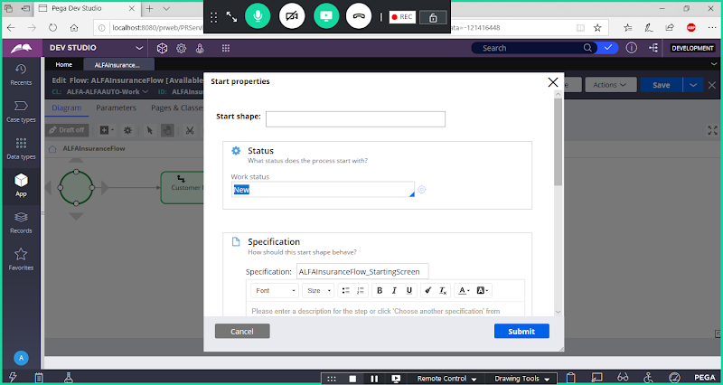

**Submit**

**Open Customer Assignment:**

**Go t o Advanced settings-> Assignment details-> Case Status**

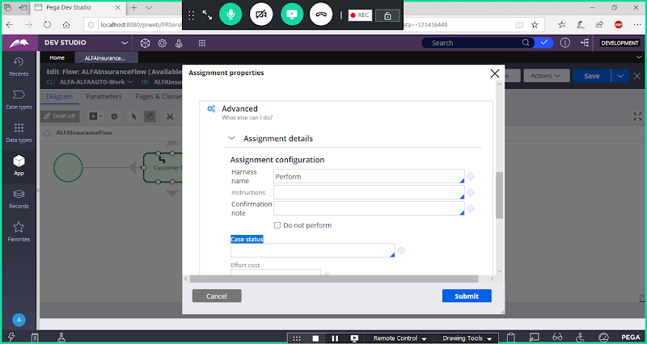

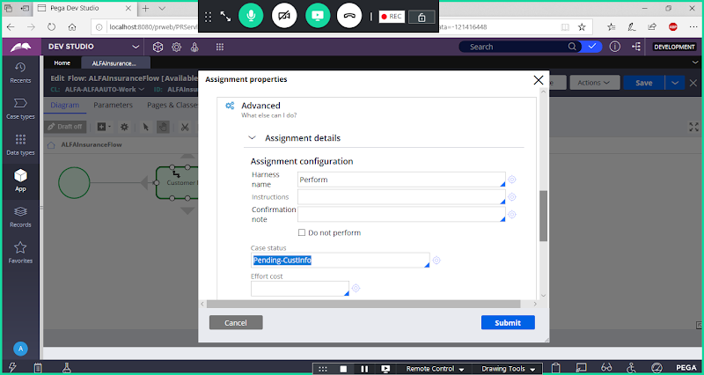

**Submit**

**Open Personal Vehicle Assignment:**

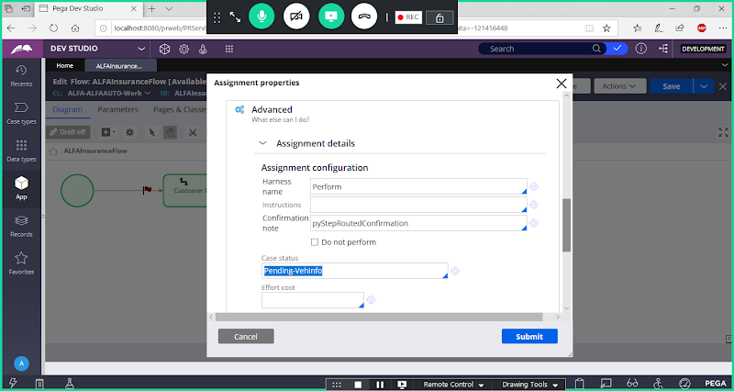

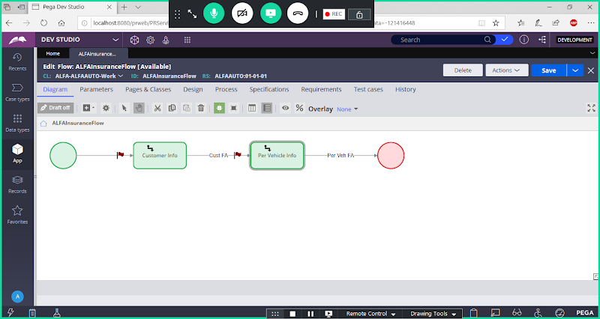

**Open End Shape:**

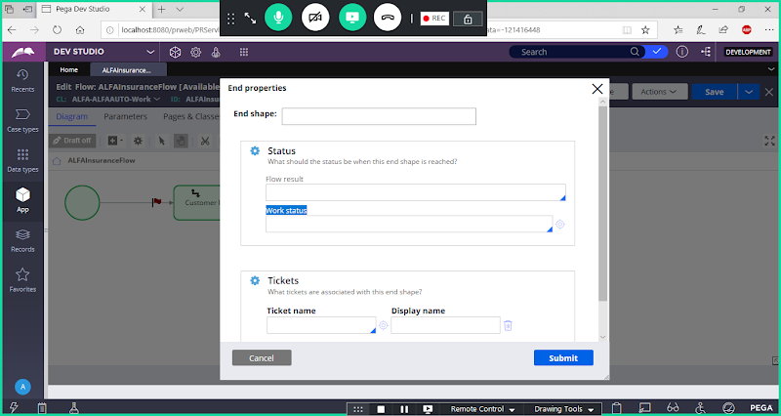

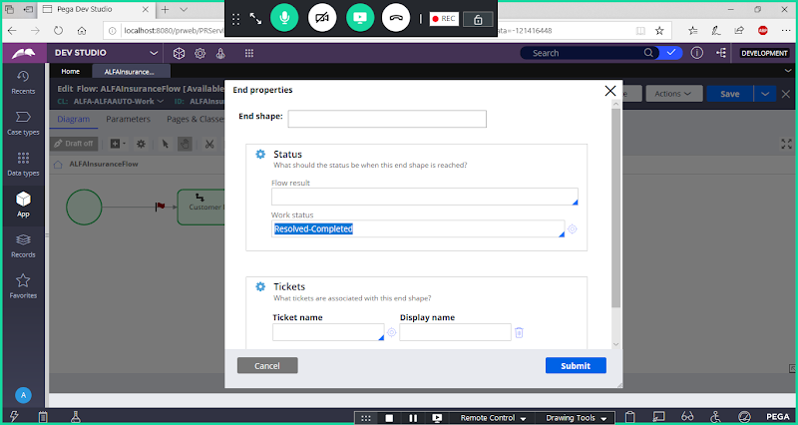

**Submit**

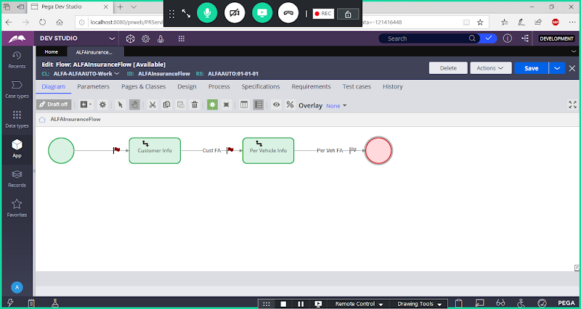

**Save Flow**

**Run Insurance Flow**

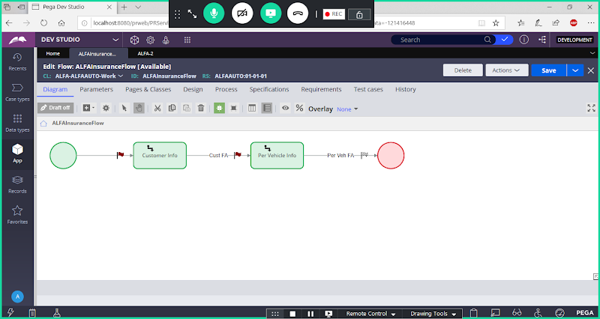

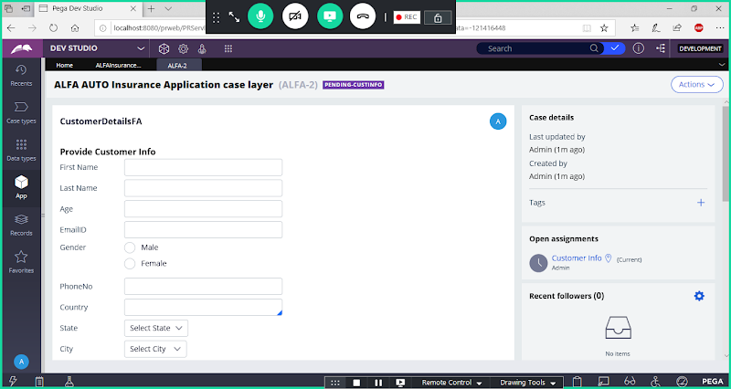

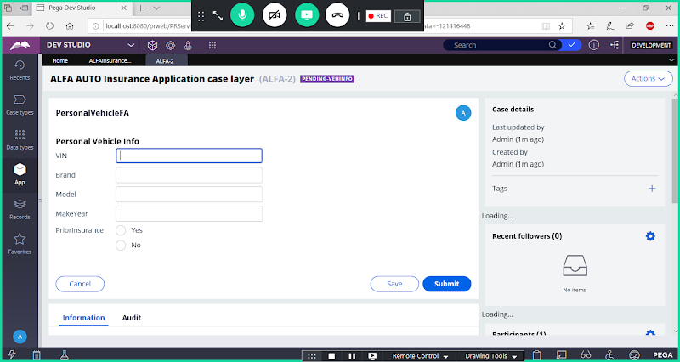

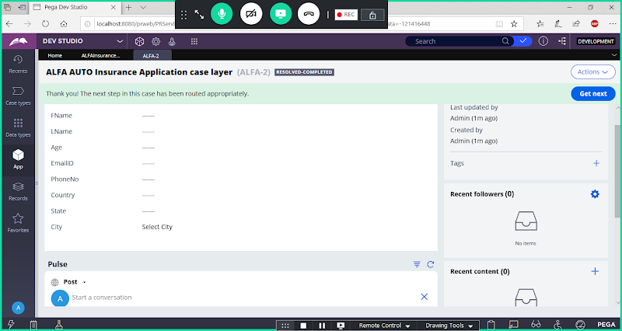

**We can see status Next to Work Object ID**

**Now Run flow multiple times & close Few WO's at Pending-CustInfo, Pending-VehInfo, Resolved-Completed**